Experiment 9
Devops Lab
Chaudhary Tuba
231410
TE IT

Aim: Learn Docker File Instructions, build an image for a sample application using Docker File. Learn Docker File Instructions, build an image for a sample application using Docker File.

Steps:

- Create a simple application file (for example app.py or index.html) that will be deployed inside Docker. This is the base code we want to run.
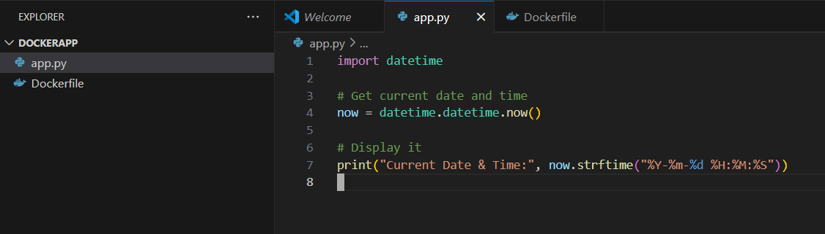

2. Write a Docker file with necessary instructions like FROM, COPY, RUN, CMD. This file defines how the image will be built.
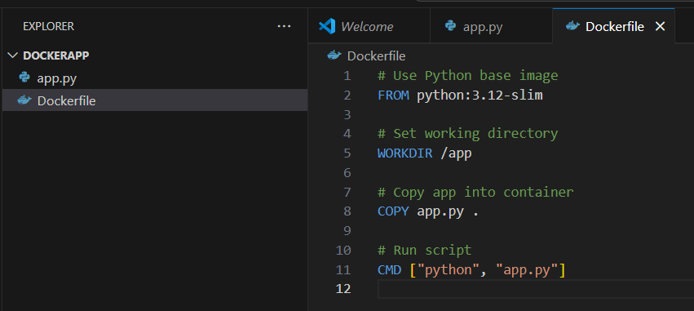

3. Open terminal and Run the command docker build -t myapp to build the image.
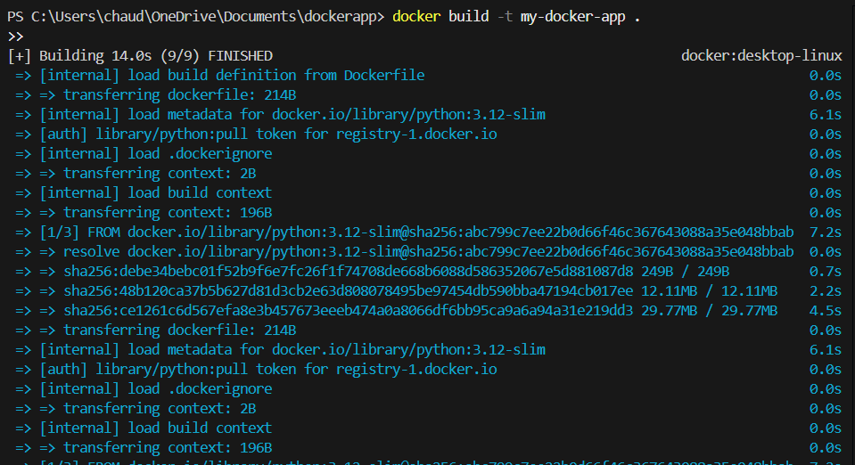

4. Run a container from the image using docker run my-docker-app. This will start the application inside Docker.
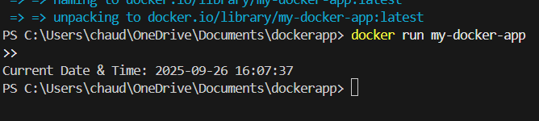

5. verify the image is created successfully by running docker images. You should see your image in the list
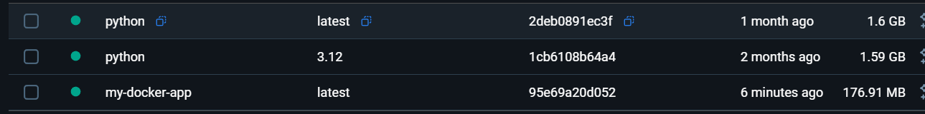

6. you can also run the file inside the docker by going to images my-docker-app and click on run you can see the output.
